**Advanced Software Engineering**

**Lab10**

Krishna Kanth Ganguri

Class ID: 21

Two APIs used

1) Sentiment analysis

2) Keyword Extraction

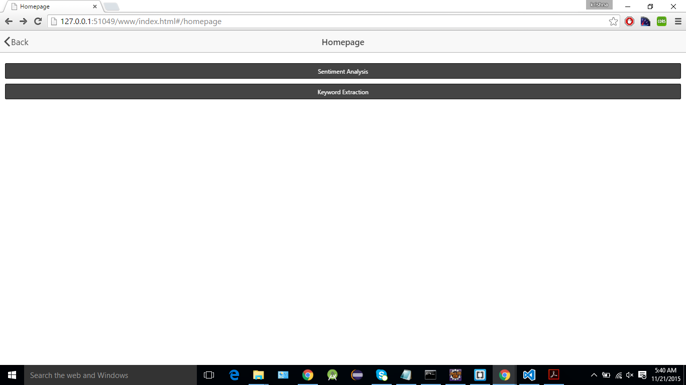

1)Sentiment Analysis

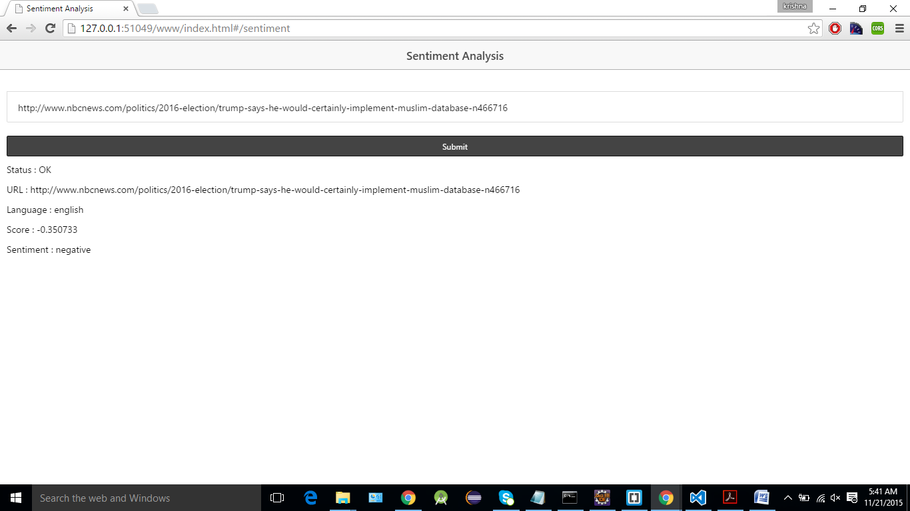

2) Keyword Extraction

